Problem Solving and testing
using Java
Week-1 Task Questions
20/07/2026 - 25/07/2026

Name: L.Rithwika
VTU:29439

week-1 Questions:

- Access and print the element at a given index in an array.
- Search for a given element in a sorted array using Binary Search.
- Find the maximum element in an array of n integers
- Given an array of integers and a positive integer K, write a program to find :The Kth smallest element
- Print all possible pairs of elements from an array of size n.
- digitSum opt: sum of even or odd digits
- Nth Fibonacci
- Is Palindrome Number?
- Sum of last digit of two given numbers

Task:1 Access and print the element at a given index in an array. Program:

import java.util.*;
import java.util.stream.*;
public class Task1 {
public static void main(String[] args) {
Scanner sc = new Scanner(System.in); System.out.print("Size: ");
int n = sc.nextInt();
List<Integer> list = IntStream.range(0, n)
.map(i -> sc.nextInt())
.boxed()
.collect(Collectors.toList()); System.out.print("Index: ");
int index = sc.nextInt();
Optional<Integer> value = list.stream()
.skip(index)
.findFirst();
value.ifPresentOrElse( System.out::println,
() -> System.out.println("Invalid Index")
);
}
}
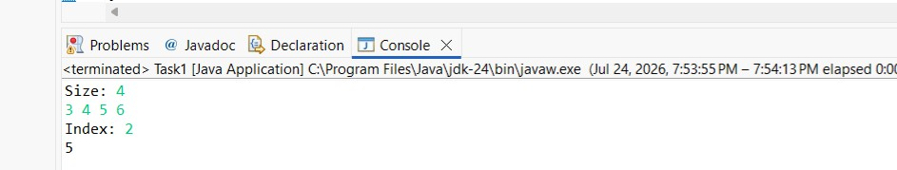
Output:

Task-2: Search for a given element in a sorted array using Binary Search.
Program:
import java.util.*;
import java.util.stream.*; public class Task2 {
public static void main(String[] args) {
Scanner sc = new Scanner(System.in); int n = sc.nextInt();
List<Integer> list = IntStream.range(0,n)
.map(i->sc.nextInt())
.boxed()
.collect(Collectors.toList()); Collections.sort(list); int key = sc.nextInt();
int index = Collections.binarySearch(list,key); System.out.println(index>=0?
"Found at "+index: "Not Found");
}
}
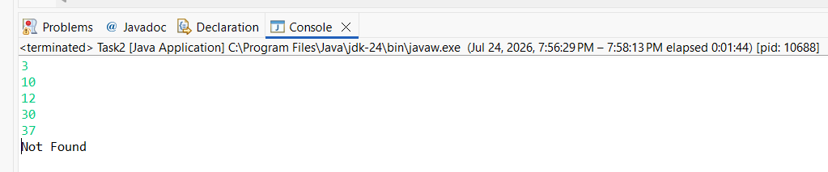
Output:

Task:3 Find the maximum element in an array of n integers Program:
import java.util.*; import java.util.stream.*; public class Task3 {
public static void main(String[] args) {
Scanner sc = new Scanner(System.in);
int n = sc.nextInt();
int max = IntStream.range(0,n)
.map(i->sc.nextInt())
.max()
.orElse(0);
System.out.println("Maximum = "+max);
}
}
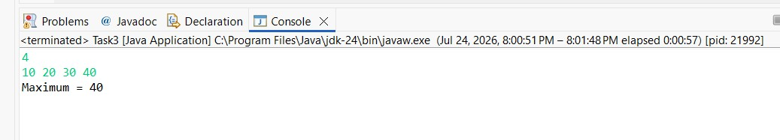
Output:

Task:4 Given an array of integers and a positive integer K, write a program to find :The Kth smallest element
Program:
import java.util.*;
import java.util.stream.*;

public class Task4 {
public static void main(String[] args) {
Scanner sc = new Scanner(System.in); int n=sc.nextInt();
List<Integer> list=IntStream.range(0,n)
.map(i->sc.nextInt())
.boxed()
.sorted()
.collect(Collectors.toList()); int k=sc.nextInt();
if(k<=list.size()) System.out.println(list.get(k-1));
else
System.out.println("Invalid K");
}
}
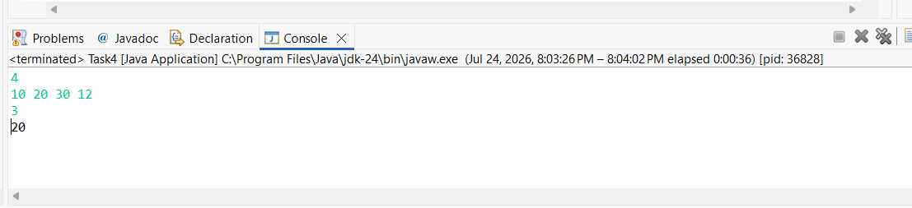
Output:

Task:5 Print all possible pairs of elements from an array of size n. Program:
import java.util.*;
import java.util.stream.*; public class Task5 {
public static void main(String[] args) { Scanner sc=new Scanner(System.in); int n=sc.nextInt();
List<Integer> list=IntStream.range(0,n)
.map(i->sc.nextInt())
.boxed()
.collect(Collectors.toList());
IntStream.range(0,n)
.forEach(i->
IntStream.range(i+1,n)
.forEach(j->
System.out.println( list.get(i)+" "+list.get(j)
)
)
);
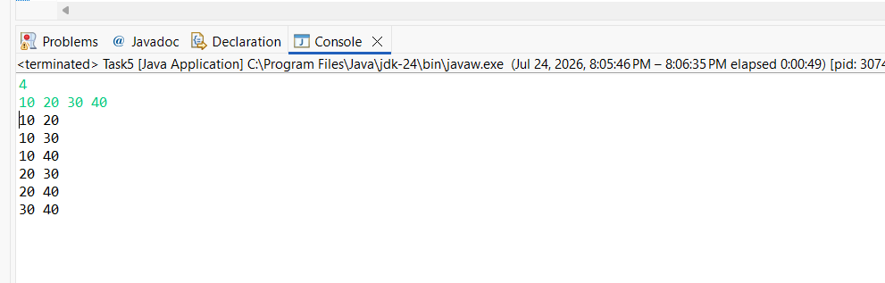
Output:

Task-6: digitSum opt: sum of even or odd digits Program:

import java.util.*;
import java.util.stream.*;

public class Task6 {
public static void main(String[] args) {
Scanner sc=new Scanner(System.in); String num=sc.next();
int even=num.chars()
.map(c->c-'0')
.filter(d->d%2==0)
.sum();
int odd=num.chars()
.map(c->c-'0')
.filter(d->d%2!=0)
.sum();
System.out.println("Even Sum = "+even); System.out.println("Odd Sum = "+odd);
}
}
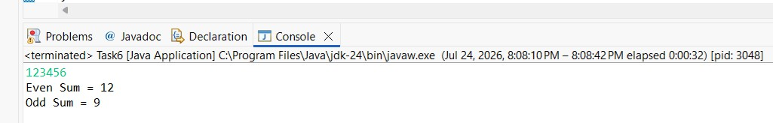
Output:

Task-7 Nth Fibonacci Program:
import java.util.stream.*;
import java.util.*;
public class Task7 {
public static void main(String[] args) {
Scanner sc=new Scanner(System.in);
int n=sc.nextInt();
Stream.iterate(new int[]{0,1}, t->new int[]{t[1],t[0]+t[1]})
.limit(n)
.map(t->t[0])
.forEach(System.out::println);

}
}
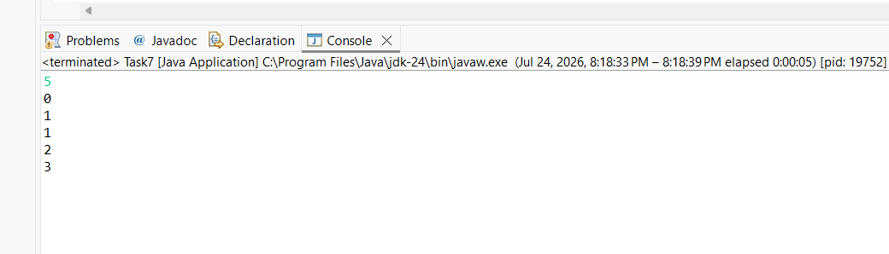
Output:

Task-8: Is Palindrome Number? Program:
import java.util.*;

public class Task8 {
public static void main(String[] args) {
Scanner sc=new Scanner(System.in);
String num=sc.next();
String rev=new StringBuilder(num)
.reverse()
.toString();
System.out.println(num.equals(rev)? "Palindrome":
"Not Palindrome"
);
}
}
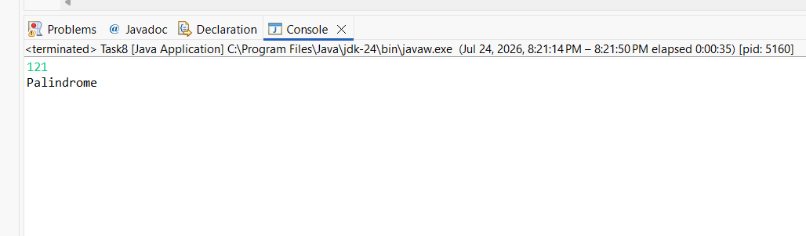
Output:

Task-9 Sum of last digit of two given numbers Program:
import java.util.*;
import java.util.stream.*; public class Task9 {
public static void main(String[] args) { Scanner sc=new Scanner(System.in);
int sum=Stream.of(sc.nextInt(),sc.nextInt())
.mapToInt(n->n%10)
.sum();
System.out.println(sum);
}
}
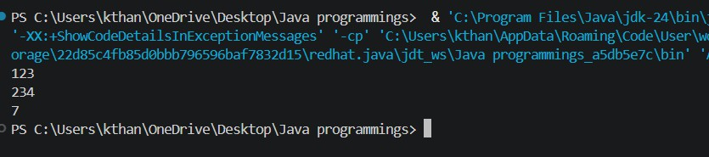
Output:

END

